Assignment

Courier Management System

Table creation :

User:

CREATE TABLE Users (

UserID INT PRIMARY KEY ,

Name VARCHAR(255),

Email VARCHAR(255) UNIQUE,

Password VARCHAR(255),

ContactNumber VARCHAR(20),

Address TEXT

);

Courier:

CREATE TABLE Courier (

CourierID INT PRIMARY KEY ,

SenderName VARCHAR(255),

SenderAddress TEXT,

ReceiverName VARCHAR(255),

ReceiverAddress TEXT,

Weight DECIMAL(5, 2),

Status VARCHAR(50),

TrackingNumber VARCHAR(20) UNIQUE,

DeliveryDate DATE

);

**CourierServices :**

CREATE TABLE CourierServices (

ServiceID INT PRIMARY KEY ,

ServiceName VARCHAR(100),

Cost DECIMAL(8, 2)

);

**Employee Table:**

CREATE TABLE Employee (

EmployeeID INT PRIMARY KEY,

Name VARCHAR(255),

Email VARCHAR(255) UNIQUE,

ContactNumber VARCHAR(20),

Role VARCHAR(50),

Salary DECIMAL(10, 2)

);

Location Table:

CREATE TABLE Location (

LocationID INT PRIMARY KEY ,

LocationName VARCHAR(100),

Address TEXT

);

Payment Table:

CREATE TABLE Payment (

PaymentID INT PRIMARY KEY ,

CourierID INT,

LocationID INT,

Amount DECIMAL(10, 2),

PaymentDate DATE,

FOREIGN KEY (CourierID) REFERENCES Courier(CourierID),

FOREIGN KEY (LocationID) REFERENCES Location(LocationID)

);

Insert into user:

INSERT INTO User (UserID, Name, Email, Password, ContactNumber, Address)

VALUES

(101, 'John Doe', 'johndoe@example.com', 'password123', '1234567890', '123 Main St, City, Country'),

(102, 'Jane Smith', 'janesmith@example.com', 'password456', '9876543210', '456 Oak St, City, Country'),

(103, 'Alice Johnson', 'alicejohnson@example.com', 'password789', '5556667777', '789 Pine St, City, Country'),

(104, 'Bob Williams', 'bobwilliams@example.com', 'password321', '4445556666', '321 Elm St, City, Country'),

(105, 'Charlie Brown', 'charliebrown@example.com', 'password654', '3334445555', '654 Maple St, City, Country'),

(106, 'David Clark', 'davidclark@example.com', 'password987', '2223334444', '987 Birch St, City, Country'),

(107, 'Eve Turner', 'eveturner@example.com', 'passwordabc', '1112223333', '123 Cedar St, City, Country'),

(108, 'Frank Harris', 'frankharris@example.com', 'passwordxyz', '6667778888', '456 Spruce St, City, Country'),

(109, 'Grace Lee', 'gracelee@example.com', 'password111', '7778889999', '789 Willow St, City, Country'),

(110, 'Henry Miller', 'henrymiller@example.com', 'password222', '8889990000', '321 Ash St, City, Country');

**Insert into courier:**

INSERT INTO Courier (CourierID, SenderName, SenderAddress, ReceiverName, ReceiverAddress, Weight, Status, TrackingNumber, DeliveryDate)

VALUES

(201, 'John Doe', '123 Main St, City, Country', 'Jane Smith', '456 Oak St, City, Country', 5.50, 'Shipped', 'TRK123456', '2024-10-01'),

(202, 'Alice Johnson', '789 Pine St, City, Country', 'Bob Williams', '321 Elm St, City, Country', 3.25, 'In Transit', 'TRK654321', '2024-10-02'),

(203, 'Charlie Brown', '654 Maple St, City, Country', 'David Clark', '987 Birch St, City, Country', 2.75, 'Delivered', 'TRK789123', '2024-09-29'),

(204, 'Eve Turner', '123 Cedar St, City, Country', 'Frank Harris', '456 Spruce St, City, Country', 4.60, 'Shipped', 'TRK321987', '2024-10-03'),

(205, 'Grace Lee', '789 Willow St, City, Country', 'Henry Miller', '321 Ash St, City, Country', 6.00, 'In Transit', 'TRK987654', '2024-10-04'),

(206, 'David Clark', '987 Birch St, City, Country', 'Eve Turner', '123 Cedar St, City, Country', 3.10, 'Shipped', 'TRK654987', '2024-10-05'),

(207, 'Bob Williams', '321 Elm St, City, Country', 'Grace Lee', '789 Willow St, City, Country', 1.25, 'Delivered', 'TRK123789', '2024-09-28'),

(208, 'Henry Miller', '321 Ash St, City, Country', 'Charlie Brown', '654 Maple St, City, Country', 4.90, 'In Transit', 'TRK789654', '2024-10-06'),

(209, 'Frank Harris', '456 Spruce St, City, Country', 'John Doe', '123 Main St, City, Country', 5.75, 'Shipped', 'TRK321654', '2024-10-07'),

(210, 'Jane Smith', '456 Oak St, City, Country', 'Alice Johnson', '789 Pine St, City, Country', 3.85, 'Shipped', 'TRK654123', '2024-10-08');

**Insert into courier service:**

INSERT INTO CourierServices (ServiceID, ServiceName, Cost)

VALUES

(301, 'Standard Shipping', 10.50),

(302, 'Express Shipping', 25.00),

(303, 'Overnight Shipping', 40.75),

(304, 'International Shipping', 65.00),

(305, 'Same Day Delivery', 50.00),

(306, 'Next Day Delivery', 35.25),

(307, 'Freight Shipping', 150.00),

(308, 'Drone Delivery', 75.50),

(309, 'Bulk Shipping', 120.00),

(310, 'Economy Shipping', 8.75);

**Insert into employees:**

INSERT INTO Employee (EmployeeID, Name, Email, ContactNumber, Role, Salary)

VALUES

(401, ' Alice Smith’, ' alice.smith@gmail.com', '1234567890', 'Software Engineer', 60000.00),

(402, 'Bob Johnson', ' bob.johnson@gmail.com', '9876543210', 'Product Manager', 75000.00),

(403, 'carol Williams', ' carol.williams@gmail.com', '5556667777', 'HR Manager', 55000.00),

(404, 'David Brown', ' david.brown@gmail.com', '4445556666', 'DevOps Engineer', 70000.00),

(405, 'Emily Davis', ' emily.davis@gmail.com', '3334445555', 'Business Analyst', 65000.00),

(406, 'Frank Miller', ' frank.miller@gmail.com', '2223334444', 'UI/UX Designer', 50000.00),

(407, 'Grace Wilson', 'grace.wilson@gmail.com', '1112223333', 'Marketing Manager', 72000.00),

(408, 'Helen Moore', ' helen.moore@gmail.com', '6667778888', 'Data Scientist', 80000.00),

(409, 'Ian Taylor', ' ian.taylor@gmail.com', '7778889999', 'QA Engineer', 52000.00),

(410, 'john McCarthy', ' John.McCarthy@gmail.com', '8889990000', 'Project Manager', 90000.00);

**Insert into location:**

INSERT INTO Location (LocationID, LocationName, Address)

VALUES

(501, 'Head Office', '123 Main St, City, Country'),

(502, 'Branch Office 1', '456 Oak St, City, Country'),

(503, 'Branch Office 2', '789 Pine St, City, Country'),

(504, 'Warehouse 1', '321 Elm St, City, Country'),

(505, 'Warehouse 2', '654 Maple St, City, Country'),

(506, 'Distribution Center', '987 Birch St, City, Country'),

(507, 'Customer Service Center', '123 Cedar St, City, Country'),

(508, 'Research & Development', '456 Spruce St, City, Country'),

(509, 'Marketing Office', '789 Willow St, City, Country'),

(510, 'Sales Office', '321 Ash St, City, Country');

**Insert into payment:**

INSERT INTO Payment (PaymentID, CourierID, LocationID, Amount, PaymentDate)

VALUES

(601, 201, 501, 100.50, '2024-09-28'),

(602, 202, 502, 75.00, '2024-09-29'),

(603, 203, 503, 60.75, '2024-09-30'),

(604, 204, 504, 150.00, '2024-10-01'),

(605, 205, 505, 120.25, '2024-10-02'),

(606, 206, 506, 80.50, '2024-10-03'),

(607, 207, 507, 95.75, '2024-10-04'),

(608, 208, 508, 110.00, '2024-10-05'),

(609, 209, 509, 130.25, '2024-10-06'),

(610, 210, 510, 145.75, '2024-10-07');

**Task 2: Select,Where**

**1. List all customers:**

Select * from user;

+--------+---------------+--------------------------+-------------+---------------+------------------------------+

| UserID | Name | Email | Password | ContactNumber | Address |

+--------+---------------+--------------------------+-------------+---------------+------------------------------+

| 101 | John Doe | johndoe@example.com | password123 | 1234567890 | 123 Main St, City, Country |

| 102 | Jane Smith | janesmith@example.com | password456 | 9876543210 | 456 Oak St, City, Country |

| 103 | Alice Johnson | alicejohnson@example.com | password789 | 5556667777 | 789 Pine St, City, Country |

| 104 | Bob Williams | bobwilliams@example.com | password321 | 4445556666 | 321 Elm St, City, Country |

| 105 | Charlie Brown | charliebrown@example.com | password654 | 3334445555 | 654 Maple St, City, Country |

| 106 | David Clark | davidclark@example.com | password987 | 2223334444 | 987 Birch St, City, Country |

| 107 | Eve Turner | eveturner@example.com | passwordabc | 1112223333 | 123 Cedar St, City, Country |

| 108 | Frank Harris | frankharris@example.com | passwordxyz | 6667778888 | 456 Spruce St, City, Country |

| 109 | Grace Lee | gracelee@example.com | password111 | 7778889999 | 789 Willow St, City, Country |

| 110 | Henry Miller | henrymiller@example.com | password222 | 8889990000 | 321 Ash St, City, Country |

+--------+---------------+--------------------------+-------------+---------------+------------------------------+

**2. List all orders for a specific customer:**

SELECT * FROM courier WHERE SenderName = 'jane smith';



**3. List all couriers:**

Select * from courier;

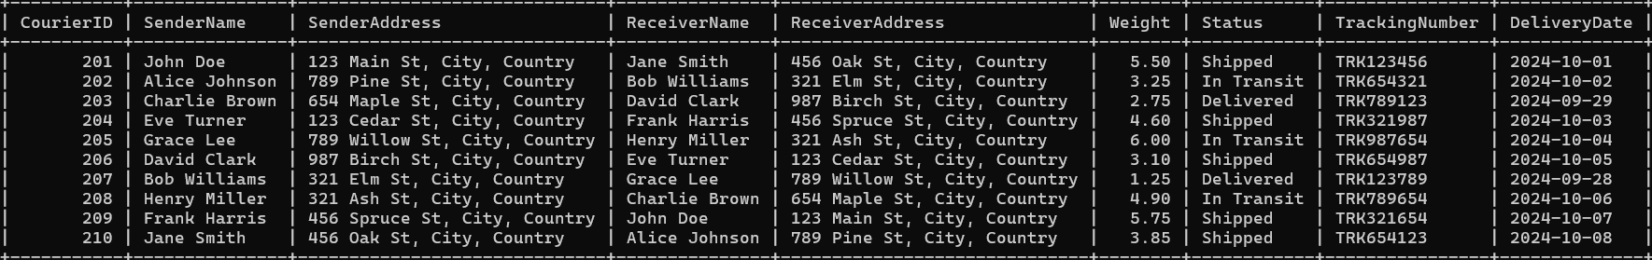

**4. List all packages for a specific order:**

SELECT * FROM Courier WHERE CourierID = 101;



**5. List all deliveries for a specific courier:**

select status from courier where CourierId = 202;

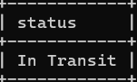

**6. List all undelivered packages:**

SELECT CourierID, SenderName, ReceiverName, Weight, Status, TrackingNumber, DeliveryDate FROM Courier WHERE Status NOT IN ('Delivered');

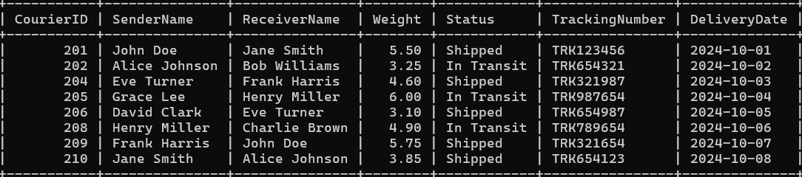

**7. List all packages that are scheduled for delivery today:**

SELECT CourierID, SenderName, ReceiverName, Weight, Status, TrackingNumber, DeliveryDate FROM Courier WHERE DeliveryDate = '2024-09-29';



**8. List all packages with a specific status:**

SELECT CourierID, SenderName,senderAddress , ReceiverName,ReceiverAddress, Weight, Status, TrackingNumber, DeliveryDate FROM Courier WHERE Status = 'In Transit';



**9. Calculate the total number of packages for each courier**.

SELECT CourierID, COUNT(*) AS TotalPackages FROM Courier GROUP BY CourierID;

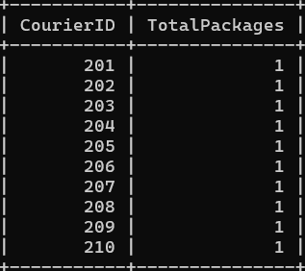

**10. Find the average delivery time for each courier**

SELECT C.CourierID, AVG(DATEDIFF(C.DeliveryDate, P.PaymentDate)) AS AverageDeliveryTime FROM Courier C JOIN Payment P ON C.CourierID = P.CourierID GROUP BY C.CourierID;

**11. List all packages with a specific weight range:**

SELECT CourierID, SenderName, ReceiverName, Weight, Status, TrackingNumber, DeliveryDate

FROM Courier WHERE Weight BETWEEN 1.0 AND 3.0;

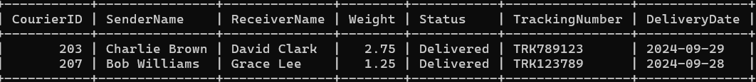

**12. Retrieve employees whose names contain 'John'**

SELECT * FROM Employee WHERE Name LIKE '%John%';



**13. Retrieve all courier records with payments greater than $50**

SELECT C.CourierID, C.SenderName, C.ReceiverName, C.Weight, C.Status, C.TrackingNumber, P.Amount, P.PaymentDate FROM Courier C JOIN Payment P ON C.CourierID = P.CourierID WHERE P.Amount > 50;

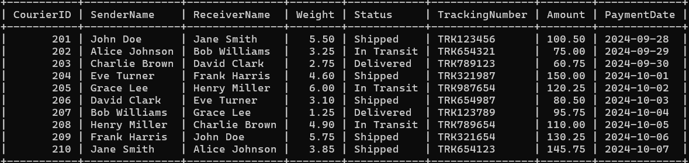

**Task 3: GroupBy, Aggregate Functions, Having, Order By, where**

**14. Find the total number of couriers handled by each employee.**

SELECT E.EmployeeID, E.Name, COUNT(C.CourierID) AS TotalCouriersHandled FROM Employee E LEFT JOIN Courier C ON E.CourierID = C.CourierID GROUP BY E.EmployeeID, E.Name;

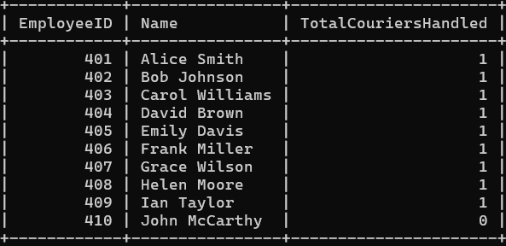

**15. Calculate the total revenue generated by each location**

SELECT L.LocationID, L.LocationName, SUM(P.Amount) AS TotalRevenue FROM Location L JOIN Payment P ON L.LocationID = P.LocationID GROUP BY L.LocationID, L.LocationName;

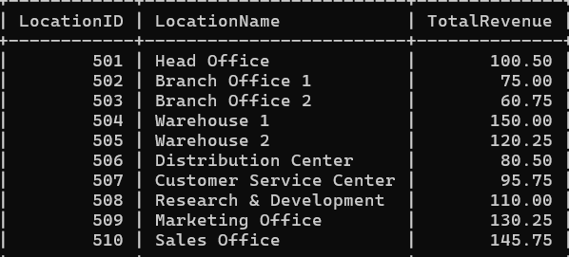

**16. Find the total number of couriers delivered to each location.**

SELECT L.LocationID, L.LocationName, COUNT(DISTINCT C.CourierID) AS TotalCouriersDelivered FROM Location L JOIN Payment P ON L.LocationID = P.LocationID JOIN Courier C ON P.CourierID = C.CourierID GROUP BY L.LocationID, L.LocationName;

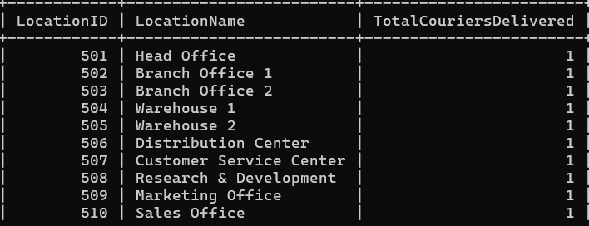

**17. Find the courier with the highest average delivery time:**

SELECT CourierID, AVG(DATEDIFF(DeliveryDate, '2024-09-20')) AS AvgDeliveryTime FROM Courier GROUP BY CourierID ORDER BY AvgDeliveryTime DESC LIMIT 1;

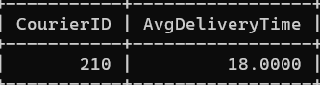

**18. Find Locations with Total Payments Less Than a Certain Amount**

SELECT L.LocationID, L.LocationName, SUM(P.Amount) AS TotalPayments FROM Location L JOIN Payment P ON L.LocationID = P.LocationID GROUP BY L.LocationID, L.LocationName HAVING TotalPayments < 100;

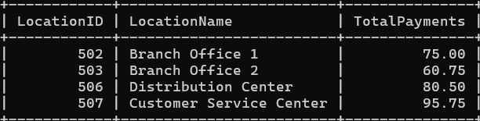

**19. Calculate Total Payments per Location**

SELECT L.LocationID, L.LocationName, SUM(P.Amount) AS TotalPayments FROM Location L JOIN Payment P ON L.LocationID = P.LocationID GROUP BY L.LocationID, L.LocationName;

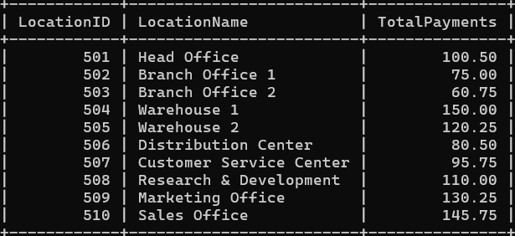

**20. Retrieve couriers who have received payments totaling more than $1000 in a specific location (LocationID = X):**

SELECT C.CourierID, C.SenderName, C.ReceiverName, SUM(P.Amount) AS TotalPayments FROM Courier C JOIN Payment P ON C.CourierID = P.CourierID WHERE P.LocationID = 509 GROUP BY C.CourierID, C.SenderName, C.ReceiverName HAVING SUM(P.Amount) > 100;

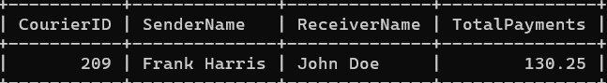

**21. Retrieve couriers who have received payments totaling more than $1000 after a certain date (PaymentDate > 'YYYY-MM-DD'):**

SELECT C.CourierID, C.SenderName, C.ReceiverName, SUM(P.Amount) AS TotalPayments FROM Courier C JOIN Payment P ON C.CourierID = P.CourierID WHERE P.PaymentDate > '2024-10-02' -- Replace with the desired date GROUP BY C.CourierID, C.SenderName, C.ReceiverName HAVING SUM(P.Amount) > 100;

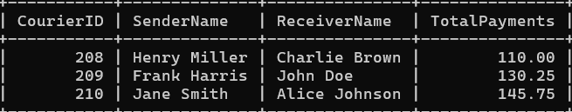

22. Retrieve locations where the total amount received is more than $5000 before a certain date (PaymentDate > 'YYYY-MM-DD')

SELECT L.LocationID, L.LocationName, SUM(P.Amount) AS TotalAmountReceived FROM Payment P JOIN Location L ON P.LocationID = L.LocationID WHERE P.PaymentDate < '2024-11-10' GROUP BY L.LocationID, L.LocationName HAVING SUM(P.Amount) > 100;

